Acc: 0.00045966444

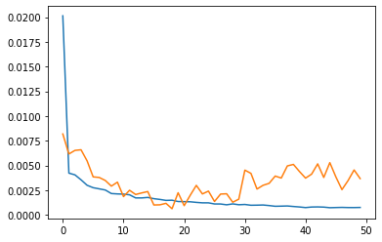

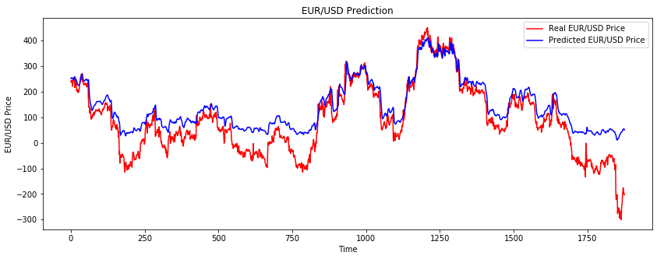

ACC:

0.000287687

Loss

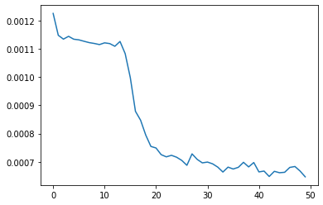

val_loss

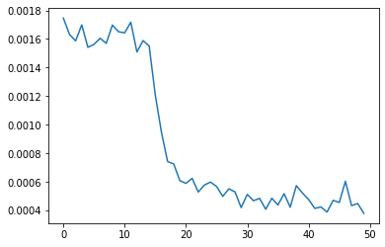

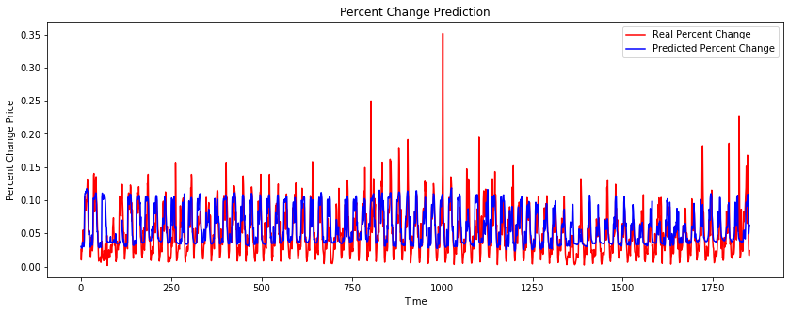

Experiment 3:

Model: "sequential_1"

_________________________________________________________________

Layer (type) Output Shape Param #

=================================================================

lstm_4 (LSTM) (None, 60, 60) 16080

_________________________________________________________________

dropout_4 (Dropout) (None, 60, 60) 0

_________________________________________________________________

lstm_5 (LSTM) (None, 60, 60) 29040

_________________________________________________________________

dropout_5 (Dropout) (None, 60, 60) 0

_________________________________________________________________

lstm_6 (LSTM) (None, 60, 80) 45120

_________________________________________________________________

dropout_6 (Dropout) (None, 60, 80) 0

_________________________________________________________________

lstm_7 (LSTM) (None, 120) 96480

_________________________________________________________________

dropout_7 (Dropout) (None, 120) 0

_________________________________________________________________

dense_1 (Dense) (None, 1) 121

=================================================================

Total params: 186,841

Trainable params: 186,841

Non-trainable params: 0

Loss

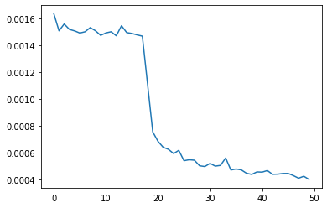

val_loss



Acc: 0.0007215007

MSE: 0.0006179639357529031

Change the Dataset:

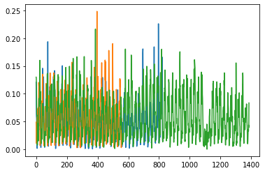

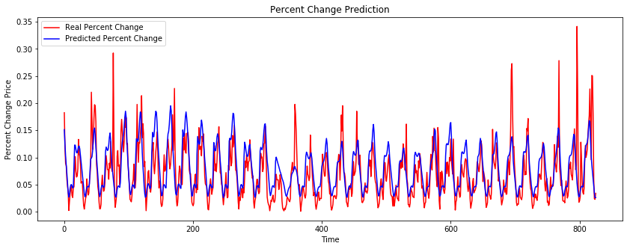

Experiment 4

Model: "sequential_1"

_________________________________________________________________

Layer (type) Output Shape Param #

=================================================================

lstm_4 (LSTM) (None, 60, 60) 16080

_________________________________________________________________

dropout_4 (Dropout) (None, 60, 60) 0

_________________________________________________________________

lstm_5 (LSTM) (None, 60, 60) 29040

_________________________________________________________________

dropout_5 (Dropout) (None, 60, 60) 0

_________________________________________________________________

lstm_6 (LSTM) (None, 60, 80) 45120

_________________________________________________________________

dropout_6 (Dropout) (None, 60, 80) 0

_________________________________________________________________

lstm_7 (LSTM) (None, 60, 120) 96480

_________________________________________________________________

dropout_7 (Dropout) (None, 60, 120) 0

_________________________________________________________________

lstm_8 (LSTM) (None, 120) 115680

_________________________________________________________________

dropout_8 (Dropout) (None, 120) 0

_________________________________________________________________

dense_1 (Dense) (None, 1) 121

=================================================================

Total params: 302,521

Trainable params: 302,521

Non-trainable params: 0

Training Percent Change:

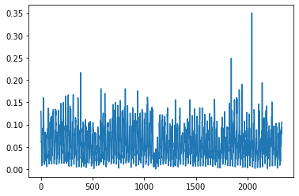

Validation

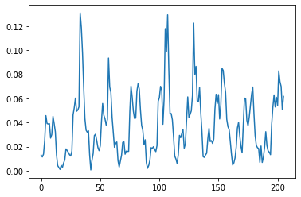

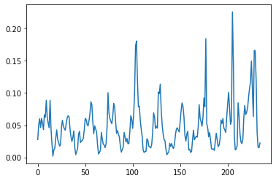

Loss:

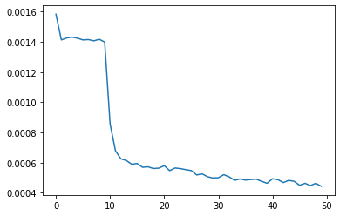

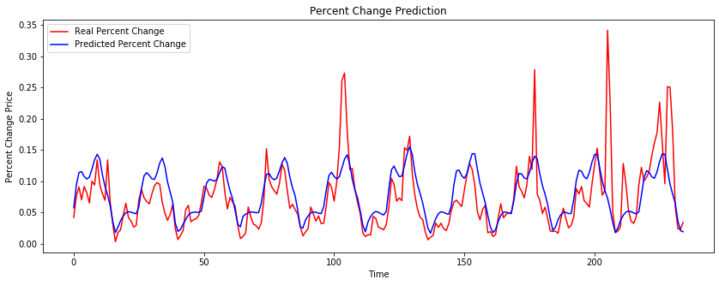

MSE:

0.001634162983332552

Experiment 5:

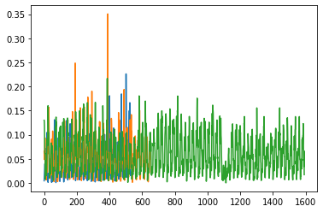

Model: "sequential_2"

_________________________________________________________________

Layer (type) Output Shape Param #

=================================================================

lstm_9 (LSTM) (None, 60, 60) 16080

_________________________________________________________________

dropout_9 (Dropout) (None, 60, 60) 0

_________________________________________________________________

lstm_10 (LSTM) (None, 60, 60) 29040

_________________________________________________________________

dropout_10 (Dropout) (None, 60, 60) 0

_________________________________________________________________

lstm_11 (LSTM) (None, 60, 80) 45120

_________________________________________________________________

dropout_11 (Dropout) (None, 60, 80) 0

_________________________________________________________________

lstm_12 (LSTM) (None, 60, 120) 96480

_________________________________________________________________

dropout_12 (Dropout) (None, 60, 120) 0

_________________________________________________________________

lstm_13 (LSTM) (None, 120) 115680

_________________________________________________________________

dropout_13 (Dropout) (None, 120) 0

_________________________________________________________________

dense_2 (Dense) (None, 1) 121

=================================================================

Total params: 302,521

Trainable params: 302,521

Non-trainable params: 0

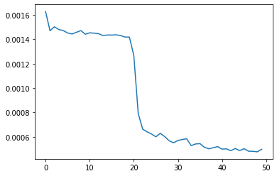

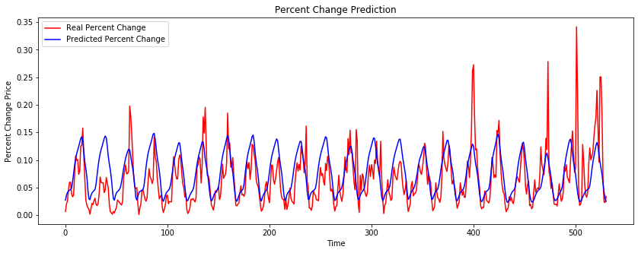

MSE: 0.0015587776594314332

Experiment:

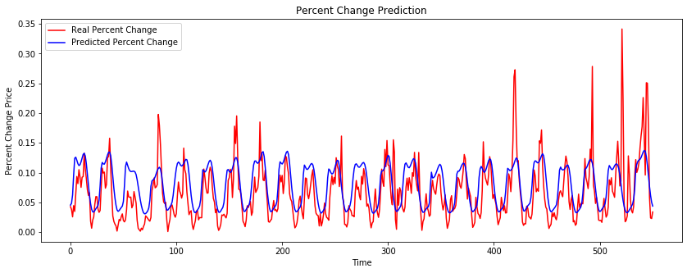

MSE: 0.0014967069328753484

Experiment 12 Nov

Loss:

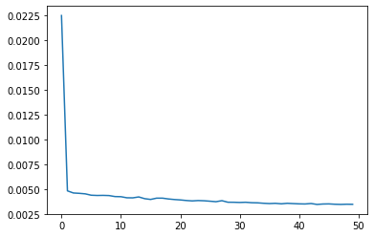

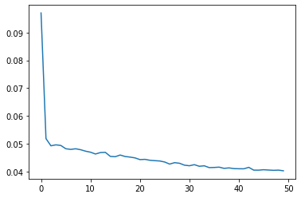

Test Pred:

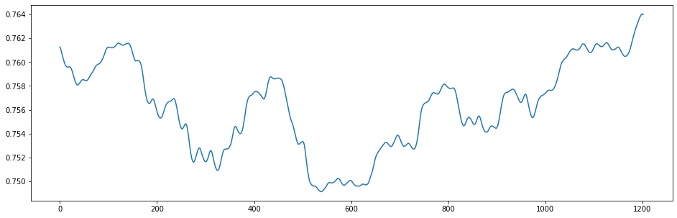

PRed VS real

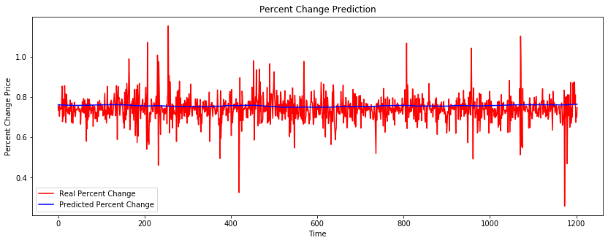

Train MAE: 0.04571749515173457

Train RMSE: 0.06724652750721954

Train MSE: 0.004522095461779235

Test MAE: 0.04571749515173457

Test RMSE: 0.06724652750721954

Test MSE: 0.004522095461779235